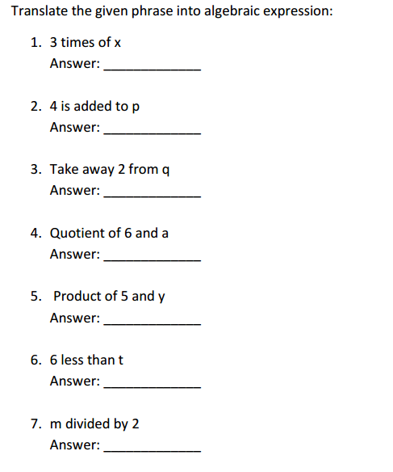

Simplify each expression by combining like terms

- -7 - 5f - 4 + 3f + 9 - 7f + 3

- -8k - k - 7k - 3k - 9k + 9k - 4k + k + 4k - 5

- -6y + 5 + 4 - 3y + 5y + 3y - 5

- 6 - 2 - 5 + t + 4 - 4 + 3t + 5t

- -3(6v - 6) - 5(-8v + 3)

- 3(3m - 1) + 5(6m + 7)

- -4(-4m - 1) - 4(7m + 3)

- (-3q + 3) + 7(8q + 1)

- -7(-4b - 9) + 9(3b + 3)
Algebraic equations
- The sum of a number and five is 15. Find the number.

- Four-fifths of a number is 4. Find the number.

- Two more than a number is 8. What is the number?

- Eight less than a number is 9. Find the number.

- Three less than a number is 2. Find the number.

- The sum of a number and three is 11. Find the number.

- The sum of a number and 10 is 13. Find the number.

- A number increased by 10 is 15. Find the number.

- A number diminished by 5 is 6. Find the number.

- Four less than a number is 3. Find the number

Evaluate each expression

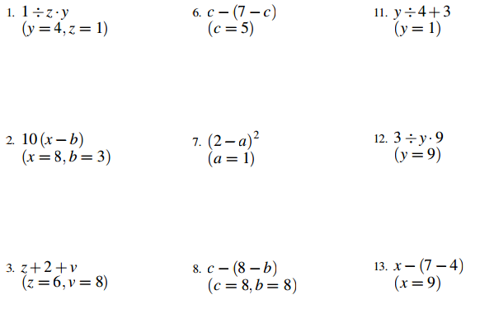

Solve – One Step Equations
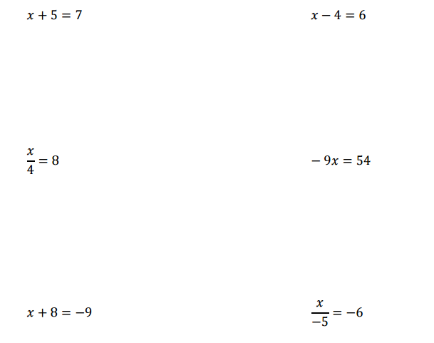

One Step Equation Problems
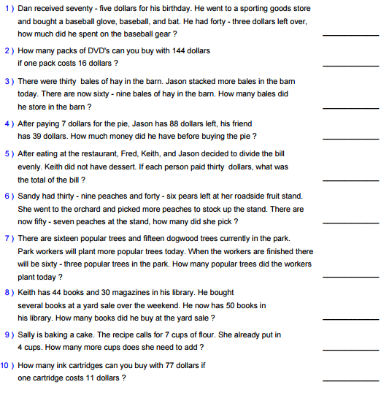

Two Step Equation Problems
